Template of a two-page extended abstract for IUTAM_TNTI (14pt)

First Author^{1*}, Second Author² and Third Author¹ (please underline the presenter, 10pt)

1. Department, University, City, Country (10pt)
2. Department, University, City, Country (10pt)
* Corresponding author: iutam_sym_tnti@buaa.edu.cn (10pt)

Abstract
Start your abstract here. The abstract should state briefly the purpose of the research, the principal results and major conclusions. Please follow the format of this template to prepare your manuscript (page size A4: 2.5 cm top and bottom margins, 2.0 cm left and right margins; format: single spacing, single column; font: Times New Roman, 11pt). Text of the abstract should not exceed 500 words, which will be used for the abstract book of the conference. The manuscript must be submitted in “.doc” format.
Keywords: Fluid Dynamics; …Said section should contain maximum 5 words separated with semi-colon.
Theme/Topic: The authors are advised to choose suitable topics according to the theme/topic consideration (see IUTAN_TNTI website for the topic list, http://ltlx.buaa.edu.cn/IUTAM_TNTI.htm).

- Introduction
This extended abstract manuscript should not exceed 2 pages. Citations should appear as [1], [2,5] or [1-3]. Examples of figure, table and equation are listed below.
It is authors’ responsibility that the submitted manuscript should follow the required format, otherwise it might be returned until it fulfils the required format.

- Materials and methods
The authors can introduce the experimental setup, measurement technique, data reduction, and accuracy estimate in this section.

- Results and discussion
The authors can introduce their results in this section.

  - Figures
Figures should be arranged in the text, centered between paragraphs. Figure title should be followed right after the picture and centered in the structure provided below.
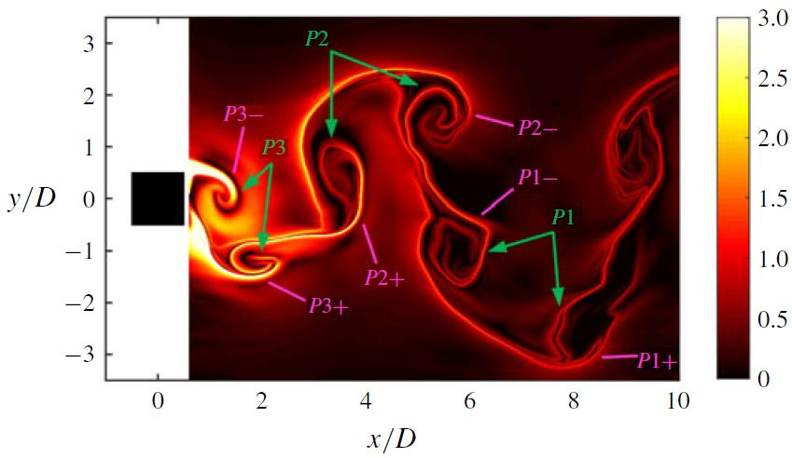
Figure 1 Caption (10pt).

  - Tables
Tables should be arranged in the text, centered between paragraphs. Table title should be headed right before the table and centered in the structure provided below.

Table 1 Velocity (10pt)
Location z (m) (11pt) | u (m/s) | v (m/s)
0.1 | 0.35 | 0.15
0.2 | 0.40 | 0.28

  - Equations
All symbols used must be properly defined in the text or through appropriate equations.
(11pt) (1)
- Conclusion
Main contain of the manuscript is ended with conclusion.

Acknowledgements
The authors can put acknowledgments here.

References
[1] Adrian RJ. Twenty years of particle image velocimetry. Experiments in Fluids, 2005, 39: 159-169
[2] Keane RD, Adrian RJ. Theory of cross-correlation analysis of PIV images. Applied Scientific Research, 1992, 49: 191-215

